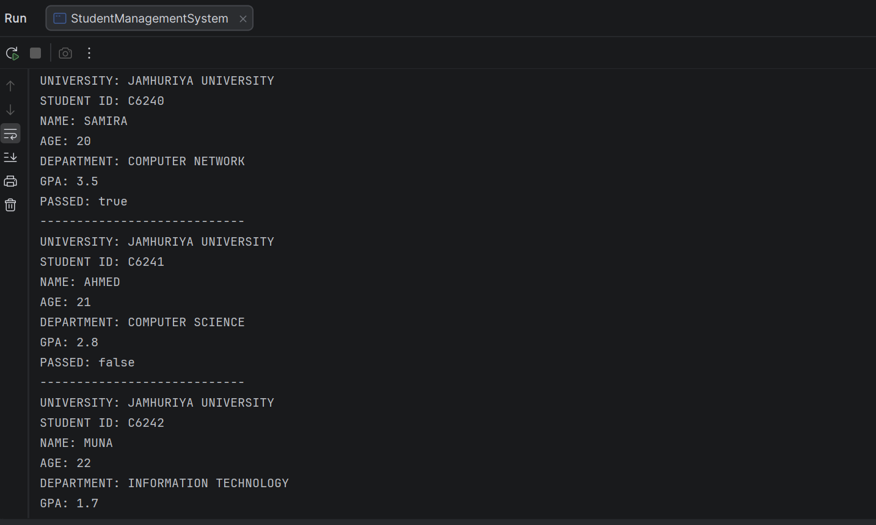
CODE 1AAD
Code-kaan waxuu mareeya xogta ardayda student class ka wuxuu kaydiyaa ID, magaca, da’da, department-ka iyo GPA-ga. displayStudentInfo() wuxuu soo bandhigayaa xogta ardayga, halka hasPassed() uu hubinayo inuu GPA-gu yahay 3.0 ama ka badan. Waxaa la sameeyay 4 arday.
.CODE 2
Code-kan waa Java OOP program oo lagu maareeyo Products. Product class-ku wuxuu kaydiyaa ID, magaca, price iyo quantity. Constructor-ku wuxuu gelinayaa xogta, halka displayProduct() uu soo bandhigayo xogta. Ugu dambayn, waxaa la sameeyay 3 products oo xogtooda la soo bandhigay
